{Lesson: Community Safety video title: community_safety_teen}
Script | On Slide Text | Animation Notes
[>>1]Molo! Kwakuhle ukukubona kwakhona! Esi sifundo simalunga nokugcina umntwana wakho ofikisayo ekhuselekile kwaye esempilweni kwaye namhlanje sifunda ngokhuseleko ekuhlaleni.  Enye indlela yokugcina umntwana wakho ofikisayo ekhuselekile kukwenza imephu yokhuseleko kunye naye. Nikunye ningachonga iindawo ezikhuselekileyo nezingakhuselekanga kwindawo ohlala kuyo.  Nanga amanyathelo amathathu okukunceda wenze imephu yakho nomntwana wakho ofikisayo:  [>>2]Zoba[pause],[>>3] Gqiba[pause], kwaye  [>>4]Xoxa.  Masifunde ngakumbi kunye!  [<<all] | [1]Ukhuseleko Ekuhlaleni  [2]ZOBA  [3]GQIBA  [4]XOXA | {cues for on-screen text animation: >> means enter Left to right  << means exit right to left. Please time with speech as indicated.}
[>>1]Inyathelo lokuqala kukuZOBA.  Kunye nomntwana wakho ofikisayo, zoba imephu yendawo enihlala kuyo. Bandakanya zonke iindawo eziphambili wena kunye nomntwana wakho ofikisayo eniya kuzo njenge [2]indlu yakho, isikolo, izitalato, iivenkile, kunye nezinye iindawo ezityelelwa ngumntwana wakho ofikisayo.  [<<all] | [1]ZOBA  [1]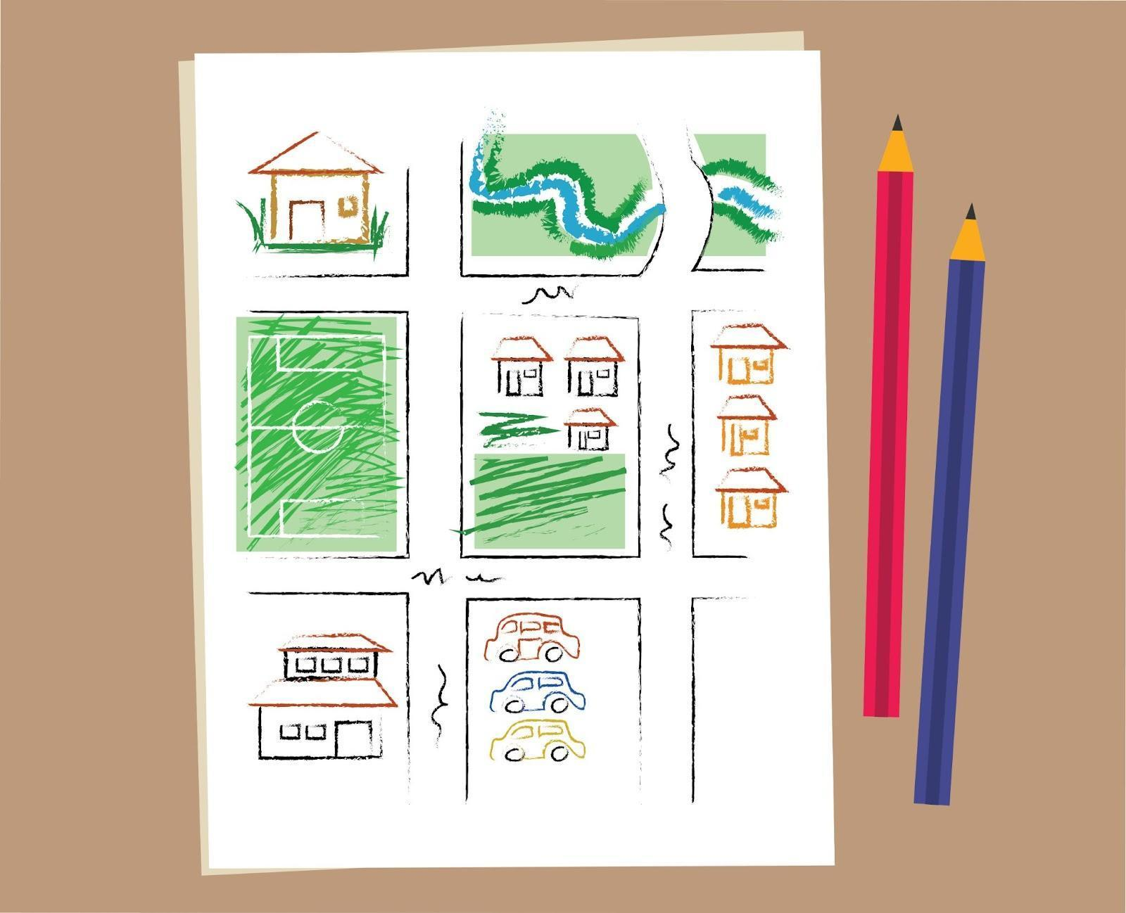 | {Begin with blank sheet (add white overlay over the drawing to show blank sheet of paper). At [2] the white shape fades out and reveals the drawing in the community_safety_draw. See reference video for example. }
[>>1]Inyathelo elilandelayo kukuGQIBA.  Thetha nomntwana wakho ofikisayo malunga neendawo ezikwimephu yakho kwaye wenze isigqibo sokuba zikhuselekile okanye azikhuselekanga. Khumbula ukuvumela umntwana wakho ofikisayo ukuba abelane ngeengcinga zakhe kwaye umamele. Basenokwazi ngaphezu kokuba ucinga malunga nendawo ekhuselekileyo okanye engakhuselekanga! Xa ugqibile ukuba zeziphi iindawo ezikhuselekileyo kumntwana wakho ofikisayo,[>>2] zoba isangqa esingqonge ezondawo. Emva koko, nqumla naziphi na iindawo ezingakhuselekanga kubantwana abafikisayo. | [1]GQIBA | {Begin with community_safety_draw on screen. Overlay community_safety_decide on [2]}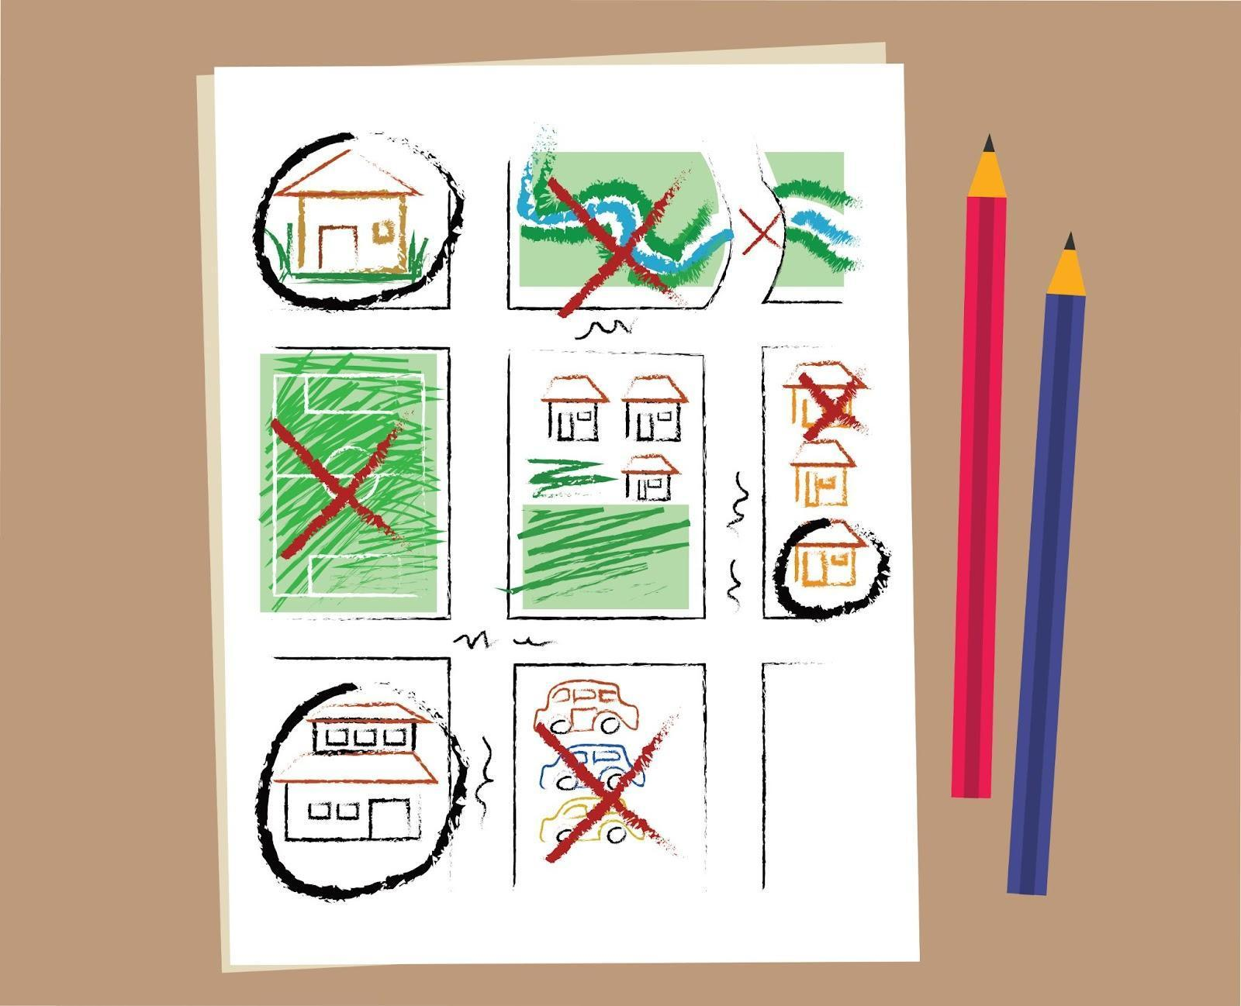
[>>1]Inyathelo lokugqibela kukuXOXA.  Ngamanye amaxesha, sizifumana sisengxakini. Xoxa apho wena kunye nomntwana wakho ofikisayo ninokufumana inkxaso kwingxaki. Oku kunokuba likhaya, isikolo, isikhululo samapolisa okanye ikliniki. [>>2] Phawula ezi ndawo ngokucacileyo ngenkwenkwezi kwimephu yakho.  [<<all] | [1]XOXA | {Begin with community_safety_decide. Overlay community_safety_discuss on [2]}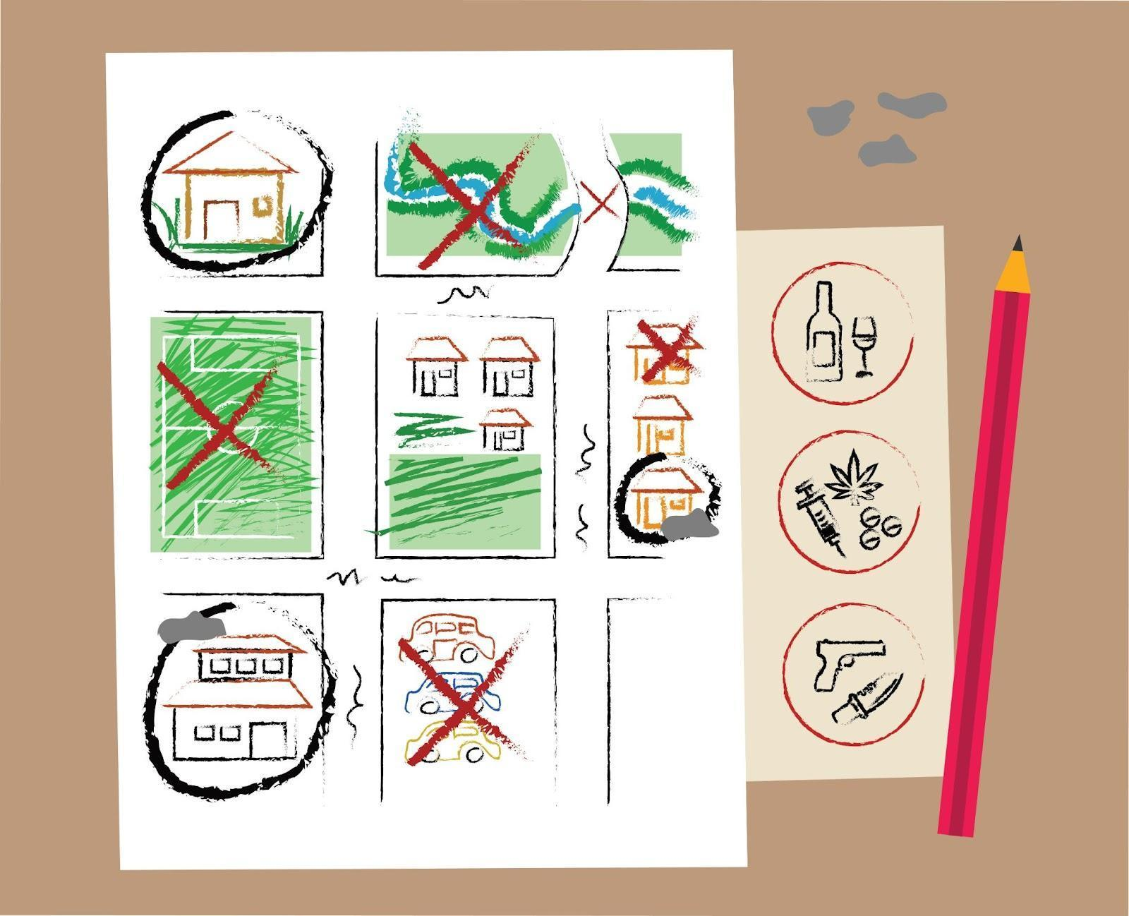
[>>1]Khumbula, iingcebiso ezintathu zokwenza imephu yokhuseleko ekuhlaleni zezi  [>>2]zoba, [pause][>>3] gqiba[pause] [>>4] kwaye xoxa.  Ukuthetha ngokhuseleko kunye nomntwana wakho ofikisayo yindlela encinci yokwenza umahluko omkhulu. Bakhumbuze ukuba banokukuxelela ngayo nantoni na engakhuselekanga eyenzekayo ngaphandle kokuba ube nomsindo. Oku kuya kukunceda ukuba wakhe ukuthembana nomntwana wakho ofikisayo.  [<<1-4, >>5]  Umsebenzi wakho wasekhaya kukwenza imephu yokhuseleko ekuhlaleni kunye nomntwana wakho ofikisayo. Ingaba unalo ixesha lokuyenza namhlanje? | [1]Ukhuseleko Ekuhlaleni  [2]ZOBA  [3]GQIBA  [4]XOXA  [5]Umsebenzi Wasekhaya:  [5]Yenza imephu yokhuseleko lwasekuhlaleni kunye nomntwana wakho ofikisayo

{Lesson: Respond to Crises video title: crises_teen}
Script | On Slide Text | Animation Notes
[ >> 1]Wamkelekile kwakhona! Namhlanje sifunda ngendlela yokusabela kumntwana wakho ofikisayo xa ekwingxaki.  Xa abantwana bethu abafikisayo besabelana ngento enzima kakhulu okanye ebacaphukisayo, kufuneka sikhumbule ukuhlala sizolile, simamele, kwaye sivuleleke ukuze bazive bexhaswa.  Nazi ezinye izinto onokuzenza ukuze uxhase umntwana wakho ofikisayo xa esabelana nawe ngento enzima:  [>>2]phefumla, [pause][>>3]mamela,[pause][>>4] phendula [pause][>>5] kwaye thuthuzela.  Masifunde ngakumbi ngala manyathelo kunye. [<<all] | [1]Phendula kwiiNgxaki  [2]PHEFUMLA  [3]MAMELA  [4]PHENDULA  [5]THUTHUZELA
[>>1] Inyathelo lokuqala kukuphefumla. [>>2]Hlala uzolile. Zibuze, "Yintoni edingwa ngumntwana wam ofikisayo ngoku?"  Ngelixa ekuqaleni sinokuziva sixhalabile, sinexhala okanye sinomsindo, kubalulekile ukuba uhlale uzolile kwaye ube khona kumntwana wakho kulomzuzu.  [<<1,2]  [>>3]] Okulandelayo, mamela. [>>4]Buza umntwana wakho ofikisayo ukuba kuqhubeka ntoni kwaye ubavumele babelane nawe ngezinto abazidingayo.. Qaphela indlela abaziva ngayo kwaye ubaxelele into oyiphawulayo ukuze bazive beviwe. Khumbula ukuxelela umntwana wakho ofikisayo ukuba ukho kwaye uyabathanda.  [<<3,4]  [>>5]Inyathelo lesithathu kukuphendula. [ >>6]Yintoni enokunceda le meko? Unokufuna ukunceda umntwana wakho ukuba athethe ngeemvakalelo zakhe okanye uqondise ingqwalasela yakhe. Okanye kusenokufuneka nixoxe ngezinto ezinokwenziwa ngokukhawuleza ukuze umncede. Unganika iziphumo kamva ukuba kuyimfuneko.  [<<5,6]  [>>7]Okokugqibela, mthuthuzele umntwana wakho ofikisayo.[>>8] Kunokuba nzima ukubona umntwana wakho ofikisayo ecaphuka okanye ebhidekile, kodwa kuninzi onokukwenza ukumxhasa. Bafuna ukuba ubamkele kwaye ubanike intuthuzelo kwiimeko ezinzima.  [<<7,8] | [1]PHEFUMLA  [2]Hlala uzolile.  [3]MAMELA  [4]Buza umntwana wakho ofikisayo ukuba kuqhubeka ntoni.  [5]PHENDULA  [6]Yintoni enokunceda umntwana wakho ofikisayo ngoku?  [7]THUTHUZELA  [8]Thuthuzela umntwana wakho ofikisayo.
[>>1]Khumbula, ungasoloko ubhala UNCEDO kwi-ParentText ukufumana uludwe lwabafowunelwa kwindawo ohlala kuyo ngenkxaso yonxunguphalo. Basenokukwazi ukunceda. [<<1] | UNCEDO | {[1]Overlay image help_template}
[>>1]Kunokuba nzima ukubona umntwana wakho ofikisayo ekhathazekile okanye ebhidekile, kodwa khumbula ukuba kuninzi onokukwenza ukumxhasa ngexesha lobunzima. Uyiphethe lento, ungumzali omhle kakhulu!  [>>2-5]  Landela la manyathelo xa umntwana wakho ofikisayo esabelana ngento enzima. Ukuxhasa umntwana wakho ofikisayo kwingxaki kuya kubafundisa indlela yokuxhasa abanye ngamaxesha anzima.  [<<all] | [1]Phendula kwiiNgxaki  [2]PHEFUMLA  [3]MAMELA  [4]PHENDULA  [5]THUTHUZELA
[>>1]Kumsebenzi wakho wasekhaya, [>>2] Fumana ixesha elizolileyo lokuthetha nomntwana wakho ofikisayo malunga neengxaki ezinokuthi zenzeke.[>>3] Xoxa ngento omawuyenze xa inokwenzeka.[>>4] Phinda undwendwele uMsebenzi weMephu ukuchonga eminye imithombo yenkxaso ekuhlaleni. [>>5] Kwaye mbulele umntwana wakho ofikisayo ngokuzinika ixesha lokuncokola ngale nto.  Ingaba unalo ixesha lokwenza oku namhlanje? | [1]Umsebenzi Wasekhaya:  [2] Thetha nomntwana wakho ofikisayo ngeengxaki ezinokubakho.  [3] Xoxa ngento omawuyenze xa isenzeka.  [4] Phinda ujonge imephu yokhuseleko ekuhlaleni kwaye uchonge eminye imithombo yenkxaso ekuhlaleni.  [5] Mbulele umntwana wakho ofikisayo. | {Animate sentences to script either as bullets or in paragraph form. Overlay community_safety_discuss on [3]  If there is not space to have [2]-[5] on screen together, bring in [2] and [3] as indicated, then exit before bringing in [4] and [5].}

{lesson: Prevent Sexual Violence video title:sex_violence_teen}
Script | On Slide Text | Animation Notes
[>>1] Wamkelekile kwakhona! Kwakuhle ukukubona kwakhona.  Kwisifundo sanamhlanje sifunda ngokuthintela ubundlobongela obuphathelene ngezesondo. Kunokuba nzima ukucinga ngomntwana wakho ofikisayo ukuba ukwimeko eyingozi kodwa ukuqonda ubunyani bakhe kunye neengozi ezinokuthi zimehlele kunokusinceda ukuba simgcine ekhuselekile.  Sinokunceda abantwana bethu abafikisayo bazi indlela yokusebenzisa iingcinga kunye namazwi abo kwiimeko ezinobungozi ukuze bahlale bekhuselekile. Kwenza umahluko omkhulu!  Kwimeko eyingozi, sinokungazi ukuba senze ntoni kwaye sikhenkceze okanye siphendule ngendlela enomsindo - oku kuqhelekileyo. Ezi zixhobo zinokukunceda ugcine wena nomntwana wakho ofikisayo nikhuselekile: [>>2]yazi,[>>3] yibone, [>>4] kwaye uyithethe.  Masizihlolisise ezi zinto kunye.[<<all] | [1]Thintela ubundlobongela obuphathelene nezesondo  [2]YAZI  [3]YIBONE  [4]YITHETHE
[>>1] Okokuqala, yazi. Wazi umahluko phakathi kobudlelwane obunempilo nobungenampilo. [>>2}Khumbula, ukuba uyahlaselwa, ayilotyala lakho. Uvumelekile ukuba uthethe kwaye wenze oko kufunekayo ukuze uhlale ukhuselekile kwaye ubaleke - ungakhathazeki malunga nokuba abanye banokucinga ntoni. Unamandla kwaye ufanele ukukhuselwa.[<<1,2]  [>>3] Okulandelayo, yibone. [>>4}Xa umntu ekwenza (okanye omnye umntu) uzive ungakhululekanga ngento ayithethayo okanye ayenzayo, ayisoze ilunge loo nto! Sonke sinelungelo lokuziva sikhuselekile, ingakumbi ekhaya. Landela ukubethelwa kwakho. Xa uziva uhlaselwa ngamazwi okanye ngezenzo, injongo yakho kukubaleka.  [<<3,4]  [>>5] Okwesithathu, yithethe. Ilizwi lakho linokunqanda uhlaselo oluninzi. [>>6] Cacisa, uzithembe, kwaye ungqale. [>>7]Thetha usebenzisa ilizwi lakho, ulwimi lomzimba, kunye nokujongana kwamehlo. Ukuba awuziva ukhuselekile, ungenza nantoni na ukuze ubaleke.  [<<6,7]  Ukusebenzisa ilizwi lakho kunokubonakala ngokwahlukileyo kwiimeko ezahlukeneyo. Ungakhwaza [>>8]"Hayi!", [>>9]]biza uncedo,[>>10] wenze ngendlela engaqhelekanga ukubhida umhlaseli,[>>11] okanye uthethathethwano.  [<<8-11]  [>>12]Nazi ezinye izinto onokuthi uzithethe okanye uzikhwaze ukunqanda imeko enzima:  "Ndiza kufowunela amapolisa ukuba unokundibamba kwakhona."  "Musa ukubamba iimpundu zam!"  "Andidingi kukhweliswa motweni, enkosi! Kwixa elidlulileyo ndakhweliswa emotweni, ndaphalaza!"  "Ndiza kukunika ifowuni yam ukuba uyandiyeka ndihambe."  [<<12]  [ >>13]Cinga ngento obuya kuyenza kwimizekelo ekwesi sifundo. Akukho mpendulo engafanelekileyo! | [1]YAZI  [2]Yazi ukuba asilo tyala lakho.  [3]YIBONE  [4]Qaphela xa ungakhuselekanga.  [5]YITSHO  [6]Caca, zithembe kwaye utsho nqgo.  [7] Sebenzisa ilizwi lakho, ulwimi lomzimba kunye nokudibana kwamehlo.  [8] “HAYI!”  [9] Cela uncedo  [10]Yenza ngendlela engaqhelekanga  [11] Thethathethana  [13] Ubuya kwenza ntoni wena? | {[8] add a megaphone icon overlaid inline with the text ( after text) to emphasise shouting}  {[12] add emoji or simple line graphic icons/images to illustrate the sentence. Forexample, a blue police light or police car for sentence 1 which talks about the police}
[1]Ukuba wonzakaliswa ngomnye umntu, khumbula ukuba ayilotyala lakho. [2] Cela uncedo kumntu omthembileyo, kwaye uqinisekise ukuba umntwana wakho ofikisayo uyazi ukuba unokuxelela nantoni na ukuze nifumane isisombululo kunye.  [<<all] | [1]Ayilo tyala lakho.  [2]Cela uncedo kumntu omdala othembekileyo | {keep [5] up}
[>>1]Khumbula, ungasoloko ubhala uncedo kwi-ParentText ukufumana uluhlu lwabafowunelwa kwindawo yakho yokuhlala ngenkxaso yonxunguphalo. Basenokunceda.[<<1] | UNCEDO | {[1]Overlay image help_template}
[>>1,2]Umsebenzi wakho wasekhaya kukunceda umntwana wakho okwiminyaka efikisayo azilungiselele ngokuphinda esi sifundo kunye. Ukuphinda olu hlobo lwesifundo bhala "THINTELA." Ingaba ungayenza namhlanje? | [1]Umsebenzi Wasekhaya: [2]Bhala "THINTELA" kwaye uphinde esi sifundo nomntwana wakho ofikisayo.

{Lesson:Knowing Basics of Online Safety video title: online_safety_teen}
Script | On Slide Text | Animation Notes
Molo kwakhona! Isifundo sanamhlanje simalunga nendlela yokugcina umntwana wakho ofikisayo ekhuselekile kwi-intanethi.  Abantwana abafikisayo bachitha ixesha elininzi kwi-intanethi. Ukunxibelelana kuyabanceda bahlale benethemba kwaye bafunde ngakumbi, kodwa kukwakho nemingcipheko ethile kunye neengozi. Ukugcina umntwana wakho ofikisayo ekhuselekile kwi-intanethi linyathelo elibalulekileyo lokubanceda babe yinxalenye yehlabathi ledijithali.  Xa kuziwa kukhuseleko lwe-intanethi, kukho iingcebiso ezine ekufuneka uzigcine engqondweni:  [>>2]funda,  [>>3]khusela,  [>>4]yakha imikhwa,  [>>5]kwaye yakha ukuthemba.  Kuninzi esiya kwabelwana ngako kangangokuba siya kugubungela ukhuseleko lwe-intanethi kwizifundo ezibini.  [<<4,5]Namhlanje, siqwalasela iingcebiso [pause] ukufunda [pause] kwaye ukukhusela.  Kwisifundo esilandelayo siza kugubungela [pause] ukwakha imikhwa [pause] kunye nokwakha ukuthemba.  Masiqalise.  [<<all] | [1]Ukwazi iZiseko zoKhuseleko kwi-Intanethi  [2]FUNDA  [3]KHUSELA  [4]YAKHA IMIKHWA  [5]YAKHA UKUTHEMBA | {Please refer to example video for additions of icons. }
[>>1]Okokuqala, funda ngeengozi zokuba kwi-intanethi:  [>>2]UMXHOLO: Umntwana wakho angadibana nomxholo onobungozi okanye umxholo ocinga ukuba awubafanelanga, njengobundlobongela, ulwimi olundlongo, okanye amanyala. [<<2]  [>>3]UQHAGAMSHELWANO: Abantu abadala banokuzenza ngathi baselula baze bacele imifanekiso yesondo okanye badibane nomntwana wakho okwiminyaka efikisayo ngeqonga le-intanethi.[<<3]  [>>4] INDLELA YOKUZIPHATHA: Maxa wambi, abafikisayo okanye abantu abangaziwayo banokuthetha okanye benze izinto ezenzakalisayo kwi-Intanethi..[<<4,5] | [1]UKUFUNDA:  - [2]Umxholo  - [3]Uqhagamshelwano  - [4]Indlela yokuziphatha
[>>1]Okulandelayo, khusela. Gcina umntwana wakho ofikisayo ekhuselekile kwi-intanethi.  [>>2]Thetha nomntwana wakho ofikisayo malunga nokuba zeziphi ii-apps kunye newebhusayithi ezikhuselekileyo nezingakhuselekanga. Qinisekisa ukuba ninengxoxo malunga nokuba kutheni! [<<2]  [>>3]Nceda umntwana wakho afunde ukwenza amagama ayimfihlo aqinileyo ukukhusela izixhobo zakhe. [<<3]  [>>4]Fundisa umntwana wakho ofikisayo ukuba kufuneka agcine iinkcukacha zobuqu ziyimfihlo, kuquka iifoto okanye iividiyo zakhe. Into engena kwi-intanethi ihlala ikwi-intanethi![<<1,4] | [1]KHUSELA  - [2]Thetha nomntwana wakho ofikisayo malunga nee-apps ezikhuselekileyo  - [3]Nceda umntwana wakho okwiminyaka efikisayo ukuba afunde ngee-password ezinamandla  - [4] Xelela umntwana wakho ofikisayo ngento efanele igcinwe bucala
[1]Kwiseshini elandelayo, siza kuqhubeka nokufunda ngokhuseleko lwe-intanethi. Namhlanje,[<1>>2]umsebenzi wakho wasekhaya kukubuza umntwana wakho ukuba enze ntoni ukuze ahlale ekhuselekile kwi-intanethi. Unokufumanisa ukuba sele becinga ngokhuseleko lwe-intanethi. Mncome umntwana wakho ngayo nayiphi na imizamo ayenzayo. Ungathetha nomntwana wakho ofikisayo namhlanje? | [1]Yazi iZiseko zoKhuseleko kwi-Intanethi  Funda ✅  Khusela  Yakha Imikhwa  Yakha Ukuthemba  [2]Umsebenzi Wasekhaya:  Buza umntwana wakho ofikisayo ukuba benza ntoni ukuze bahlale bekhuselekile kwi-intanethi

{Lesson: Build Habits and Trust Online video title: habits_online_teen}
Script | On Slide Text | Animation Notes
[>>1]Wamkelekile kwakhona kwi-ParentText ! Esi sifundo siyaqhubeka nokufunda kwethu malunga nokugcina abantwana abafikisayo bekhuselekile kwi-intanethi.  Ukugcina umntwana wakho ofikisayo ekhuselekile kwi-Intanethi linyathelo elibalulekileyo lokumnceda abe yinxalenye yehlabathi ledijithali.  [>>2,3,4,5]Sele uzifundile iindlela zokukhusela umntwana wakho kwi-intanethi [<<2]funda kunye no [<<3]khusela kwisifundo esidlulileyo.  Namhlanje, sifunda indlela yokwakha imikhwa kunye nokwakha ukuthemba.  Ukulungele ukuqalisa?[<<all] | [1]Yakha Imikhwa kwaye nokuThemba kwi-Intanethi  [2]FUNDA  [3]KHUSELA  [4]YAKHA IMIKHWA  [5]YAKHA UKUTHEMBA | {Please refer to example video for additions of icons. }
[>>1]Inyathelo elilandelayo kukwakha imikhwa. Misela imikhwa ekhuselekileyo ye-intanethi ekhaya.  [>>2] Cwangcisa amaxesha angenafowuni endlwini yakho, njengaxa usitya, umsebenzi wasekhaya, okanye ebhedini.  Beka imida kwixesha elichithwa ngumntwana wakho ofikisayo kwi-intanethi.  [3]Yenza imithetho kunye nomntwana wakho malunga nokuba ngubani anokuncokola naye kwi-Intanethi. Kukhuselekile ukuncokola kuphela nabantu abasele bebazi. Abamele babelane ngenkcazelo yobuqu kwigumbi labucala lokuncokola okanye nabantu abangabaziyo.  [>>4]Phambi kokuba ugcwalise iifomu ezicela iinkcukacha zakho, jonga ukuba idilesi yewebhu iqala ngo-https://. IiWebhusayithi eziqala ngo-http:// zinokungakhuseleki.[<<4]  [>>5] Kulutsha olukhulileyo, unokubanceda benze amagama ayimfihlo aqinileyo kwiiakhawunti zabo. Iipassword ezilungileyo zezi:  [pause][6] zinde  [pause] [7]ungafaki iinkcukacha zobuqu ezicacileyo njengegama lakho okanye usuku lokuzalwa;  [pause][8] kwaye iquka oonobumba abakhulu nabancinci, amanani kunye neesimboli.[<<5-8]  [>>9] Xelela umntwana wakho ofikisayo ukuba angacofi kwii-pop-ups ezicela ukuba azikhuphele okanye ahlawule nantoni na. | [1]YAKHA IMIKHWA  [2]Misela amaxesha okungabikho kwefowuni endlwini yakho  [3]Yenza imithetho yokuba ngubani azakuthetha naye kwi-intanethi  [4]Khangela iidilesi zewebhu  https://  http://  [5]Seta Amagama Ayimfihlo Omeleleyo:  [6]Ibende  [7]Ungafaki iinkcukacha zakho  [8]YENZE iquke oonobumba abakhulu nabancinane, amanani, kunye neesimboli  [9] Lumkela ii-pop-ups | {Animate password details to explain better. See reference Video}
[>>1]Okokugqibela, YAKHA UKUTHEMBA nomntwana wakho ofikisayo  [>> 2]Nikunye, jongani iiwebhusayithi, amakhasi onxibelelwano, imidlalo, kunye nee=apps azisebenzisayo.  [>>3]Buza imibuzo - oku kukunceda ukuba ufunde ngakumbi malunga nezinto anomdla kuzo umntwana wakho ofikisayo!  [>>4]Ukuba ufumana nantoni na enikhathazayo kunye, thetha ngayo nomntwana wakho. [>>5]Ukuba ufuna inkxaso, bhala UNCEDO emva kokuba ugqibe isifundo sanamhlanje okanye nangaliphi na ixesha ofuna inkxaso eyongezelelweyo.  [>>6]Xelela umntwana wakho ukuba kufuneka axelele umntu omdala ukuba uziva esoyika, engakhuselekanga okanye ekhathazekile ngento ethile kwi-intanethi.  Fundisa umntwana wakho ofikisayo ukuba xa umntu angamaziyo emnika izipho, njengengqekembe ezi-virtual, efuna ukutshintshiselana ngeefoto kunye neenkcukacha zakhe, aze amxelele ukuba ayigcine iyimfihlo, kufuneka akuxelele. | [>>1]YAKHA UKUTHEMBA  [2]Jongani iiwebhusayithi, amakhasi onxibelelwano, imidlalo kunye nee-apps ezisetyenziswa ngumntwana wakho ofikisayo, kunye  [3]Buza imibuzo  [4]Thethani ngezinto ezixhalabisayo kunye  [6] Xelela umntwana wakho ofikisayo ukuba uziva esoyika okanye engakhuselekanga, kufuneka axelele umntu omdala | {[5]Overlay image help_template}
[>>1]Kanye njengoko ugcina umntwana wakho ofikisayo ekhuselekile kwihlabathi lokwenyani, kufuneka uqiniseke ukuba bakhuselekile kwihlabathi ledijithali. Ngokulandela la manyathelo unokubakhusela kwaye uqinisekise ukuba ixesha labo kwi-Intanethi likhuselekile ukuze bahlale belisebenzise ekufundeni. Wenza umsebenzi omhle kakhulu!  [<<1]  [>>2] Nantsi into onokuyenza nomntwana wakho ofikisayo namhlanje ukuqala ukuqinisekisa ukuba uhlala ekhuselekile kwi-intanethi:  [>>3]  Okokuqala, yiba nencoko nomntwana wakho ofikisayo malunga nendlela abanokusebenzisa ngayo i-intanethi kunye nezixhobo ngendlela ekhuselekileyo.  [>>4]  Okulandelayo, thetha malunga nokuba zeziphi iisayithi okanye ii-apps ezingakhuselekanga. Xoxani ukuba kutheni.  [>>5]  Okokugqibela, mncome umntwana wakho ofikisayo ngendlela alunge ngayo ekusebenziseni iwebhu!  Ingaba wena nomntwana wakho ofikisayo ningawugqiba lo msebenzi namhlanje? | [1]Yakha Imikhwa kunye nokuThemba kwi-Intanethi  [2]Umsebenzi Wasekhaya  [3] Yiba nencoko nomntwana wakho ofikisayo malunga nendlela abanokusebenzisa ngayo i-intanethi kunye nezixhobo ngendlela ekhuselekileyo.  [4]Thetha malunga nokuba zeziphi iisayithi okanye ii-apps ezingakhuselekanga kwaye ngoba?  [5] Mncome umntwana wakho ofikisayo ngendlela alunge ngayo ekusebenziseni iwebhu ngokukhuselekileyo!

